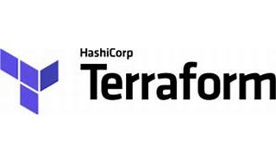



Explore

Certainly! [In a nutshell, **Terraform** is an **infrastructure as code (IaC)** tool that allows you to build, modify, and version your cloud and on-premises resources in a safe and efficient manner1](https://bing.com/search?q=what+is+terraform)[2](https://developer.hashicorp.com/terraform/intro)[3](https://www.ibm.com/topics/terraform).

Here are **five free reference links** where you can learn more about Terraform:

1. [**Terraform Official Documentation**](https://developer.hashicorp.com/terraform/intro): Start with the official documentation to understand the basics and explore various features.
2. [**IBM’s Introduction to Terraform**](https://www.ibm.com/topics/terraform): Learn about Terraform’s capabilities and how it solves infrastructure challenges.
3. [**HashiCorp’s Terraform Tutorials**](https://developer.hashicorp.com/terraform/tutorials): Follow step-by-step tutorials to build, change, and destroy infrastructure using Terraform. You’ll find guides for AWS, Azure, Google Cloud Platform, Docker, and more.
4. [**Techbeatly’s Free Terraform Courses**](https://www.techbeatly.com/terraform-free-courses/): Access free courses, including HashiCorp Terraform Associate Certification, Terraform for DevOps Beginners, and more.
5. [**Geekflare’s Terraform Tutorial for Beginners**](https://geekflare.com/terraform-for-beginners/): Dive into an introductory tutorial that covers the fundamentals of Terraform.

Happy learning! 🚀🌟